

**Draft (May 2021)**

**International Water Management Institute**

**New Delhi**

Drought Proofing Assessment:

Kulans catchment, Sehore, Madhya Pradesh

Contents

1 Kulans catchment 3

1.1 Land Use & Soil 3

1.2 Cropping pattern 4

1.3 Irrigation & Domestic 4

2 Drought risk assessment 5

3 Drought proofing assessment 7

4 Application of drought proofing tool 8

4.1 Baseline scenario 9

4.1.1 Water balance 9

4.1.2 Crop water requirement and irrigation water requirement 10

4.1.3 Crop water requirement met and crop yield 10

4.1.4 Drought proofing and Quadrant 11

5 Plan water management interventions 12

5.1 Water management interventions scenarios 13

5.2 Interventions impact on mild drought 14

5.3 Interventions impact on moderate drought 17

5 Cost and benefit analysis 20

6 Conclusion and recommendation 21

Appendix A: Input data 23

# **Kulans catchment**

Kulans catchment is located in the Sehore Block of Sehore District in Madhya Pradesh, India (**Figure 1**a). Watershed is part of Kulans river part of bigger Ganga basin. Total area of the watershed is 4328 hectares (ha). The study area has a Tropical Savanna climatebordering on a hot semi-Arid climateunder Koppen climate classification. South-West monsoon covers most of the annual precipitation. The average annual rainfall is 1109 mm (1980-2017), of which more than 90% is concentrated in the four monsoon months of June to September (**Figure 1**b). Also, rainfall is associated with high inter-year variability (Pai et al., 2014). The average annual mean temperature is 25.8 ᵒC with minimum temperature observed in January with a mean of 18.8 ᵒC and maximum temperature is observed in May with a mean of 33.2 ᵒC (Srivastava et al., 2009).

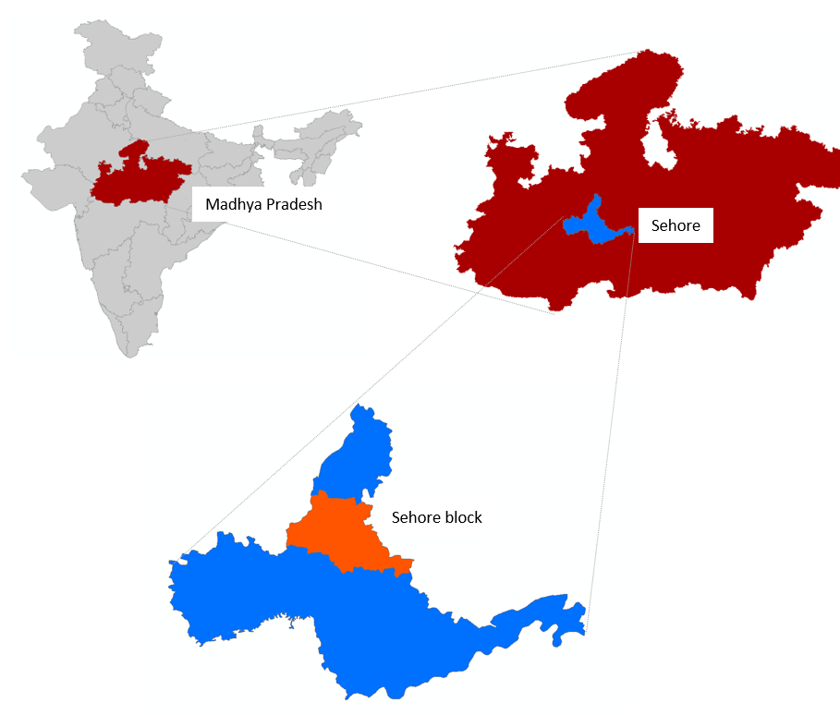

**Figure 1: a) Study area map b) Mean monthly rainfall and temperature**

## **Land Use & Soil**

Watershed is predominantly cultivated with agricultural area occupying ~ 94 % of the watershed area (Table 1). Black cotton is the predominant soil type in the area.

Table 1: Land use details of Kulans catchment

|  |  |  |
| --- | --- | --- |
| S.no | Description | Area (ha) |
| Total Agri catchment Area (ha) | | 4328.00 |
|  | Agriculture Area (Net cultivated sown area) | 4064.00 |
|  | Fallow | 47.00 |
|  | Built-up / Settlements | 90.00 |
|  | Waterbodies | 29.00 |
|  | Forest | 12.00 |
|  | Other | 86.00 |

## **Cropping pattern**

There are two main cropping seasons in the watershed: Kharif (overlapping monsoon season, May to Sep) and Rabi (post-monsoon season) ( **Figure 2**). In the kharif season, the major crop grown is Soyabean, followed by a small cultivated area of Maize. Kharif crops are primarily taken as rainfed crops with provision for supplemental irrigation if necessary. In the rabi, the major crop is wheat, and it covers almost all the area. Wheat is completely irrigated and about 80 % of irrigated area water is sourced from groundwater. Availably of irrigation makes cropping intensity high (~ 197 %) in the watershed. No rainfall and limited groundwater in summer mean that no crop is taken during summer.

|  |  |  |  |  |  |  |  |  |  |  |  |
| --- | --- | --- | --- | --- | --- | --- | --- | --- | --- | --- | --- |
| **Jun** | **Jul** | **Aug** | **Sep** | **Oct** | **Nov** | **Dec** | **Jan** | **Feb** | **Mar** | **Apr** | **Jun** |

Kharif (monsoon) season

Rabi (post monsoon) season

Zaid (summer) season

Soyabean

Maize

Wheat

**Figure 2: Cropping calendar of watershed**

## **Irrigation & Domestic**

Of the total net cropped area, 90 % is partially or fully equipped with irrigation. Groundwater is the main source of irrigation in the district covering more ~ 85 % of the irrigated area followed by surface irrigation from tanks and small reservoirs (ponds, check dams). Groundwater extraction in the Sehore district and Sehore block is moderate but the overall stage is classified as safe with a stage of extraction (total abstraction/total recharge) at 62 % and 67 %, respectively (CGWB, 2019).

Groundwater in the district is found under semi-confined to confined conditions under hard rock aquifers of Deccan trap basalts which cover 85 % of the area and a small area under alluvium aquifer (CGWB, 2012). Groundwater occurs mainly under confined conditions and the yield of wells in this formation varies from 1 to 5 liter per second. Groundwater in the catchment is primarily abstracted through deep tube wells (~ 50 %) and shallow tube wells (~ 25 %) whereas a very small area is covered by dug wells. Pre-monsoon groundwater levels range from 4-17 m and post-monsoon groundwater levels range from 4-12 m.

# **Drought risk assessment**

For assessing ITC agri-catchments, the widely used rainfall index ‘*Standard Precipitation Index’ (SPI) (*World Bank, 2019; Sönmez et al., 2005) is used. SPI is calculated by taking the difference of the precipitation from the mean for a particular time step, and then dividing it by the standard deviation and is based on the long-term precipitation data (Sönmez et al., 2005). For SPI, only rainfall data is needed which is the primary causative factor of drought thus making SPI easy to calculate.



SPI is a dimensionless index where negative values indicate drought and positive values wet conditions with a range of SPI values can be categorized across different intensities (Table 2).

Table 2: SPI values-based drought categories

|  |  |
| --- | --- |
| **SPI values** | **Drought category** |
| **0 to -0.99** | Mild drought |
| **-1.00 to -1.49** | Moderate drought |
| **-1.50 to -1.99** | Severe drought |
| **< -2.0** | Extreme drought |

SPI is calculated based on monthly rainfall data of the last 38 years (1980-2017). To segregate seasonal and annual drought, drought frequency for the annual, kharif, and rabi season is calculated separately. Shorter periods (seasonal droughts) are important to assess agricultural droughts whereas longer/annual droughts are used to assess hydrological droughts. Based on an assessment of seasonal and annual droughts, effective planning and designing of interventions to mitigate drought can be done.

Based on the seasonal and annual rainfall assessment, % of years under different drought categories is calculated (**Table 3**). Results show that mild drought is the most occurring drought in the regions occurring almost every third year. After that, moderate drought has the highest frequency of occurring relatively more in the rabi season. The occurrence of moderate and severe drought is relatively low as compared to mild droughts. Annual time series of rainfall with drought category (Figure 3) shows that of last 15 years, 8 years have been mild drought year. This suggests that drought-proofing activities should actively focus on drought proofing mild droughts.

**Table 3:** **Drought intensity and their frequency for different periods.** The percentage indicates the percent of total assessed years classified under different drought categories.

|  |  |  |  |
| --- | --- | --- | --- |
|  | **Kharif (Jun-Sep)** | **Rabi (Oct-Jan)** | **Annual** |
| **No drought** | 50% | 61% | 53% |
| **Mild drought** | 34% | 24% | 34% |
| **Moderate drought** | 8% | 8% | 5% |
| **Severe drought** | 8% | 5% | 5% |
| **Extreme drought** | 0% | 3% | 3% |

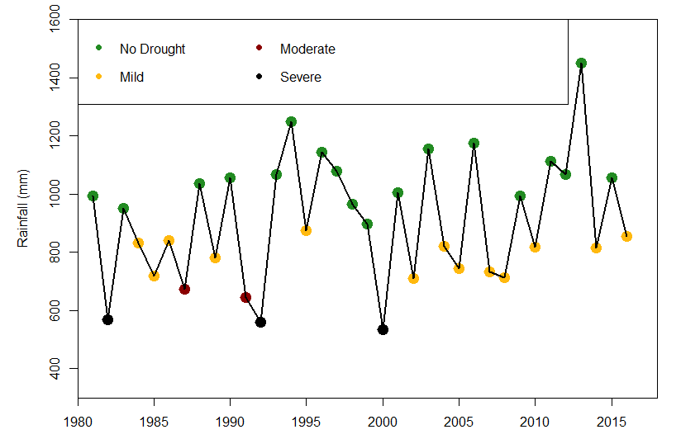

Figure 3: Annual time series of rainfall with drought category

# **Drought proofing assessment**

Drought proofing assessment is carried out using the developed conceptual drought proofing framework (**Figure 4**). In the framework, Drought proofing in a watershed is conceptualized as an interaction between water availability for crops and water use efficiency (Figure 4). At the base level, drought proofing is defined as an interaction between water availability for a crop (mm or m3 ha-1 or % of crop water needs met) and water use efficiency (Figure 4). Water availability for a crop is the water available from all the sources (rainfall, soil moisture, groundwater, and surface water storage) to meet crop water requirements. Water efficiency determines how efficiently irrigation water is used. For irrigated areas, this is the irrigation application efficiency. For rainfed areas, this can be translated to how efficiently rainfall is used.

Across a simple 2*2 plane, we can identify four distinct quadrants (**Figure 4**) with water availability for a crop on the y-axis and crop water use efficiency (WUE) on x-axis. Based on the analysis and where watershed crops lie in different rainfall years, users can identify the type and intensity of required interventions. Water availability can be increased with supply augmenting practices (storage, recharge, and soil moisture conservation) whereas water use efficiency can be increased through water saving and irrigation application efficiency measures (micro-irrigation).

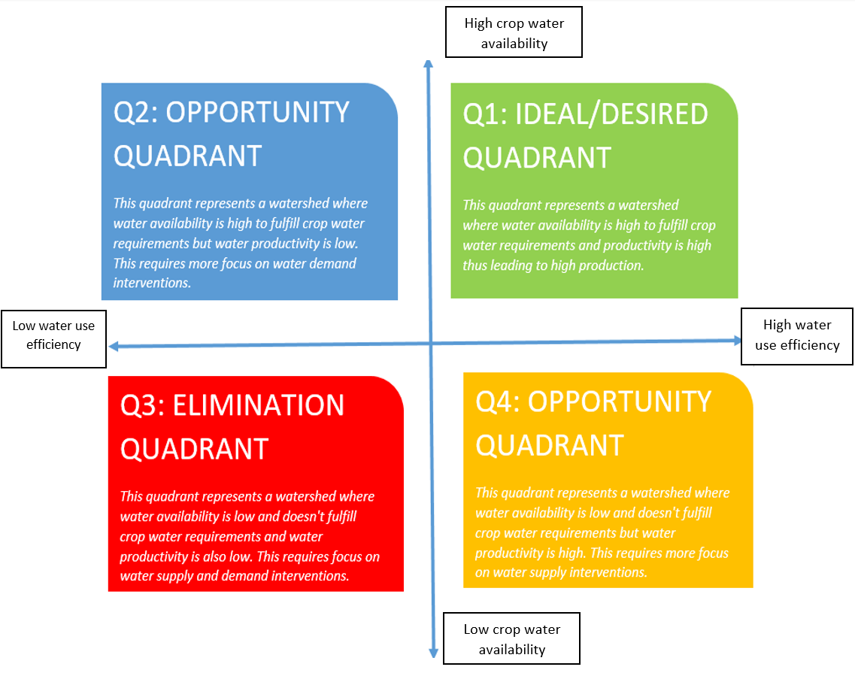

**Figure 4: Conceptual physical drought proofing framework**

With water as the key input to the drought-proofing framework (**Figure 4**), water balance tool is developed to operationalize the framework. The tool is modeled in excel spreadsheet with minimum input data requirements for simplifications. Drought Proofing Tool is developed in MS Excel + Visual Basic Editor (VBA) platform.

The water balance tool helps in site-specific water balance, crop yield, and crop requirement assessments. The two-key function of the tool is as follows:

* To assess the water balance of the study area for various hydrological conditions (dry, normal & wet years)
* To assess the impact of proposed water management interventions in achieving drought proofing

Here we provide the results of the application of the water balance tool for the watershed. For details on the methodological and workflow of the tool, please check Technical Manual, User Manual, and Case Study example.

# **Application of water balance tool**

The first step is the entry of input data. Input data to tool covers: Land use and soil data, crop details, irrigation and domestic and rainfall and temperature (see user manual). While a brief of each is provided in the study area description and summarised in Table 4, and detailed input data is given in Appendix A.

**Table 4:** **Overview of input data.** Detailed input data is given in Appendix A

|  |  |
| --- | --- |
| Parameter | Information |
| Land use | Table 1 |
| Soil | Black cotton (100 %) [Clay loam] |
| Crops | Kharif: Soyabean and Maize |
| Rabi: Wheat |
| Irrigation | Crop wise irrigated area, Groundwater irrigation 85 %, default irrigation efficiency of 0.5 |
| Rainfall and temperature | Daily rainfall, mean, max and min temperature data (20 years) |

The flow diagram in **Figure 5** below gives the steps involved in running the tool and planning water management interventions.

* Step1: Input data is entered in the tool. See Appendix A and the user manual.
* Step 2: The baseline scenario is simulated. The baseline scenario is where no water management interventions are in place.
* Step 3: Water balance, crop water requirements, and crop water deficit results are analyzed
* Step 4: Based on analyzed results, water management interventions are planned and entered in the tool as scenarios
* Step 5: Scenarios are simulated and their impact on drought-proofing is analyzed. If drought-proofing is not realized, steps 3 and 4 are repeated until the best results on drought proofing are obtained.

Accordingly, results in the upcoming section are given in the same order. As mild and moderate droughts are most frequent, drought-proofing assessment is carried out for the same.

**Figure 5: Conceptual workflow of applying drought proofing tool**

### **Baseline scenario**

### **Water balance**

Table 5 gives the water balance results for the watershed for the normal, mild, and moderate drought years. Normal years include all years where rainfall is above the drought threshold, including wet years. The rainfall in mild and moderate years is lesser by 29 % and 43 % relative to normal years. In normal and mild years, runoff (27-39 % of rainfall) is very high. Recharge ranges from 4-13 % of rainfall, decreasing from normal (13 %) to moderate drought years (5 %). Despite low runoff as a percent of rainfall in moderate years (13.6 %), absolute runoff is more than 100 mm showing the potential to capture in surface and groundwater storages.

Table 5: Water balance results (in mm)

|  |  |  |  |  |
| --- | --- | --- | --- | --- |
| **Year** | **Rainfall** | **Runoff** | **recharge** | **ET** |
| Normal | 1347.8 | 528.2 | 169.8 | 649.8 |
| Mild | 952.0 | 260.2 | 70.2 | 621.6 |
| Moderate | 759.0 | 103.3 | 33.2 | 622.6 |

### **Crop water requirement and irrigation water requirement**

Table 6 gives the crop water requirement (CWR) and irrigation water requirement (IWR) of each simulated crop for normal, mild, and moderate drought years. CWR of the crop is calculated based on reference evapotranspiration (ETo). As there is a slight temperature difference between drought years, CWR differs among different drought years.

Kharif Soyabean CWR (310-325 mm) and Maize CWR (400-415 mm) is relatively lower compared to wheat CWR (~ 530 mm). Irrigation water requirement (IWR) is the difference between CWR and rainfall in the crop growing period. As only Wheat is irrigated in the watershed (Appendix A, Table 1b), IWR for Wheat is estimated. IWR for wheat is very high, more than 50 % of total CWR, as post-monsoon rainfall is limited and wheat completely on residual soil moisture and irrigation.

Table 6: CWR & IWR of the crops in the watershed (in mm)

|  |  |  |  |  |  |  |  |
| --- | --- | --- | --- | --- | --- | --- | --- |
| Season | Crop | Normal | | Mild | | Moderate | |
| **CWR** | **IWR** | **CWR** | **IWR** | **CWR** | **IWR** |
| Kharif | **Soyabean** | 312.4 | - | 324.7 | - | 322.5 | - |
|  | **Maize** | 399.6 | - | 415.1 | - | 410.8 | - |
| Rabi | **Wheat** | 532.7 | 335.4 | 528.8 | 340.9 | 530.0 | 340.0 |

### **Crop water requirement met and crop yield**

CWR is met by rainfall and soil moisture in the case of rainfed crops whereas irrigated areas can also access irrigation storage to meet CWR.  Results show that for normal years, most of CWR is met for Kharif (~ 90 %). This is expected in normal years as rainfall is concentrated during the monsoon season. Even in mild and moderate drought years, the impact on Kharif crops is limited due to the concentration of rainfall during monsoon season, hence CWR is mostly met (> 80 %). This reflects that Kharif crops in the catchment are already drought proofed for recurring mild and moderate drought years with only a slight reduction in CWR met.

However, this is not the case for rabi season. Even in normal years with high rainfall and recharge, results show that only 60 % of wheat CWR can be met. This reflects that current groundwater storage in the catchment is not sufficient to meet the high IWR of wheat (Table 6). This is further aggravated in drought years where low rainfall leads to low recharge. In mild and moderate drought years, most of CWR remains unmet with CWR met of 44 % in mild drought years and 39 % in moderate drought years.

Table 7: Percent of total CWR met for each crop in different drought years

|  |  |  |  |  |  |  |  |
| --- | --- | --- | --- | --- | --- | --- | --- |
| Season | Crop | Normal | | Mild | | Moderate | |
| **Irrigated** | **rainfed** | **Irrigated** | **rainfed** | **Irrigated** | **rainfed** |
| Kharif | **Soyabean** | - | 90.6% | - | 86.6% | - | 83.7% |
|  | **Maize** | - | 91.4% | - | 87.4% | - | 87.3% |
| Rabi | **Wheat** | 58.7% | - | 44.5% | - | 39% | - |

Crop yield (as % of attainable yield) is influenced by how much CWR is met (Table 7) and how sensitive it is to water deficits (Steduto et al., 2012). Crop yields (Table 8) follow the same trend as CWR met in Table 7. The crop yield of wheat is significantly impacted in drought years. This shows that interventions should primarily focus on increasing the CWR met for wheat.

Table 8: Crop yield (as % of attainable yield) in different drought years

|  |  |  |  |  |  |  |  |
| --- | --- | --- | --- | --- | --- | --- | --- |
| Season | Crop | Normal | | Mild | | Moderate | |
| **Irrigated** | **rainfed** | **Irrigated** | **rainfed** | **Irrigated** | **rainfed** |
| Kharif | **Soyabean** | - | 92.0% | - | 88.6% | - | 86.1% |
|  | **Maize** | - | 89.2% | - | 84.3% | - | 84.1% |
| Rabi | **Wheat** | 55.1% | - | 39.1% | - | 33.0% | - |

### **Drought proofing and Quadrant**

Plotting CWR met and irrigation efficiency of the crop on drought proofing quadrant (**Figure 6**) shows which crop and what kind of interventions are needed. As discussed above, it becomes clearer from drought proofing quadrant figures that little additional interventions for kharif crop are required as CWR met is already on the higher end. Whereas for rabi crops (wheat), interventions need to be focussed on both supply and demand to improve both the CWR met and irrigation efficiency.

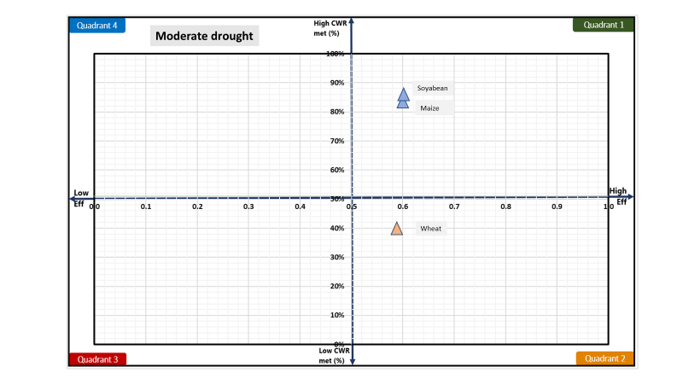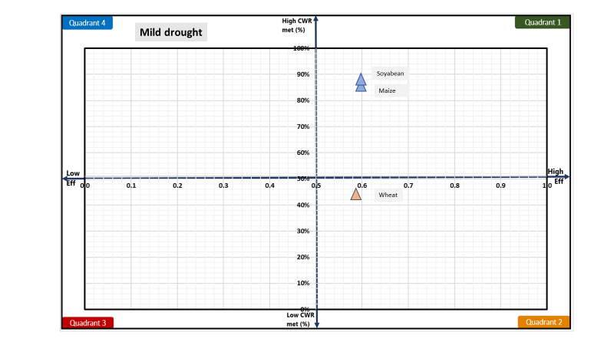

**Figure 6: Drought quadrant for mild (left) and moderate (right) drought**

# **Plan water management interventions**

Crop water balance and deficit (CWR met) shows which crops are impacted the most and drought proofing quadrant shows which interventions are needed. However, the intensity or scale of water management interventions should be planned based on how much water is available and absolute crop deficits (in m3). Crop water deficits (CWR – CWR met) can be assessed from results on CWR (Table 6) and CWR met (Table 7). Table 10 gives the crop water deficit (in m3) for all crops for mild and moderate drought years. Crop water deficit (in m3) is derived by multiplying unmet CWR (in mm) to the crop area.

As rabi wheat primarily require interventions, we focus on wheat only here. Kharif crops are already drought proofed to an extent in the catchment. Results show a high absolute water deficit for wheat for all years. This is driven by high IWR and low CWR met (%) as given in Table 7.

Absolute crop water deficit (in m3) can give an idea of the intensity of required interventions. In addition to supply measures, water-saving can be achieved through improving irrigation efficiency measures. Table 9 also gives the potential savings that can be achieved if irrigation efficiency is improved to 75 % and 90 % for all crops. Potential savings (in m3) are derived assuming all irrigation water requirement (IWR) is met through increased efficiency. Calculations show that savings from increased irrigation efficiency can potentially cover 40-75 % of absolute crop water deficits.

Table 9: Absolute crop water deficit and potential saving from increasing irrigation efficiency for mild and moderate drought years.

|  |  |  |  |  |  |  |  |  |
| --- | --- | --- | --- | --- | --- | --- | --- | --- |
| **Normal** | | | **Mild** | | | **Moderate** | | |
| **Deficit (‘000 m3)a** | **Potential savings (‘000 m3)b** | | **Deficit (‘000 m3)a** | **Potential savings (‘000 m3)b** | | **Deficit (‘000 m3)** | **Potential savings (‘000 m3)** | |
|  | Eff =0.75 | Eff = 0.9 |  | Eff =0.75 | Eff = 0.9 |  | Eff = 0.75 | Eff = 0.9 |
| 8288 | 4161 | 6935 | 10254 | 4229 | 7049 | 11737 | 4218 | 7030 |

a deficit = [CWR*(1-CWRmet(%)]*Crop area

b savings = [(IWR/effc) - (IWR/effim)]*Crop area, where effc and effim is the current and improved irrigation efficiency.

Table 10 compares the total deficit and total potential irrigation savings to available water. Available water is the runoff in the area which can be captured for storage or recharge to meet crop water deficits. The comparison shows that for normal and mild drought years, available water is more than the wheat water deficit meaning supply side interventions can potentially mitigate the drought impact. Along with irrigation improving measures, there is potential to completely mitigate the impact of mild drought. However, for moderate drought years, available water is not sufficient to meet the crop water deficit. Drought proofing moderate years potentially will require interventions focussed on increasing irrigation efficiency to improve application efficiency.

Table 10: Comparison of total available water with the total deficit and irrigation potential savings (in m3)

|  |  |  |  |  |  |
| --- | --- | --- | --- | --- | --- |
|  | Available watera | Total deficit | Potential savings [0.75] |  | Potential savings [0.9] |
| Normal | 19885 | 8288 | 4161 |  | 6935 |
| Mild | 11263 | 10254 | 4229 |  | 7049 |
| Moderate | 4469 | 11737 | 4218 |  | 7030 |

a runoff*Watershed area

## **Water management interventions scenarios**

Based on the assessed deficit, potential irrigation savings, and available water, the following initial 5 scenarios are designed and simulated (**Table 11**). Scenario 1 to 5 gradually increases the intensity of interventions. Scenarios primarily cover supply and demand side interventions.

Supply side is proposed to be augmented through storage and recharge from farm ponds, stop dams and recharge shafts. Total potential created capacity (in storage and recharge) ranges from 10-53 % and 25-100 % of available water (runoff) for mild and moderate drought years, respectively. For the demand side, sprinkler irrigation for wheat is planned. Sprinkler irrigation can improve the efficiency of irrigation to 90%. Area covered by sprinkler range from 16 % (scenario 1) to 100 % (scenario 5) of wheat area.

**Table 12** gives input parameters of the interventions added in the model. For details of parameters or step by step instructions on how to run scenarios, please see [user manual](https://drive.google.com/drive/folders/1Yi0Qt4JraRVXNljxe3DB_TAdu5VM8bhg).

**Table 11: Water management interventions under different scenarios**

|  |  |  |  |  |  |
| --- | --- | --- | --- | --- | --- |
| Scenario | Supply interventions | | | Demand interventions | |
| Number (#) | | | Area (ha) | |
| Large farm/ ponds | Stop dams | Recharge shafts | Sprinkler |  |
| 1 | 50 | 25 | 20 | 600 |  |
| 2 | 100 | 40 | 40 | 1000 |  |
| 3 | 200 | 50 | 60 | 2500 |  |
| 4 | 300 | 75 | 75 | 3722 |  |
| 5 | 400 | 100 | 100 | 3722 |  |

**Table 12: Input parameters of water management interventions**

|  |  |  |
| --- | --- | --- |
| Interventions | Impact/technical parameters | Cost, Life span, maintenance, |
| Farm ponds | Storage: 2700 m3  Depth: 2.5 m  Infiltration rate: 9 mm day-1 | Cost: 80 INR m-3  Annual maintenance: 5 %  Life span: 10 years |
| Stops dam | Storage: 4000 m3  Depth: 2.5 m  Infiltration rate: 9 mm day-1 | Cost: 120 INR m-3  Maintenance: 3 %  Life span: 15 years |
| Recharge shafts | Recharge capacity: 500 m3 day-1 | Cost: 20000 INR each shaft  Maintenance: 2 %  Life span: 15 years |
| Sprinkler | Increased efficiency: 0.75 | Cost: 25000 INR ha-1  Maintenance: 10 %  Life span: 10 |

## **Interventions impact on mild drought**

**Figure 7** shows the impact of interventions on the runoff and recharge in the watershed for mild drought years. With increasing intensity of interventions, runoff is gradually reduced, and recharge is gradually increased. Compared to the baseline scenario with no interventions, runoff is reduced by 42 % (absolute decrease of 110 mm), and recharge increased by 118 % (an absolute increase of 83 mm) in scenario 5. Similarly, the efficiency of wheat from 58% (in the baseline) to 78% (in scenario 5).

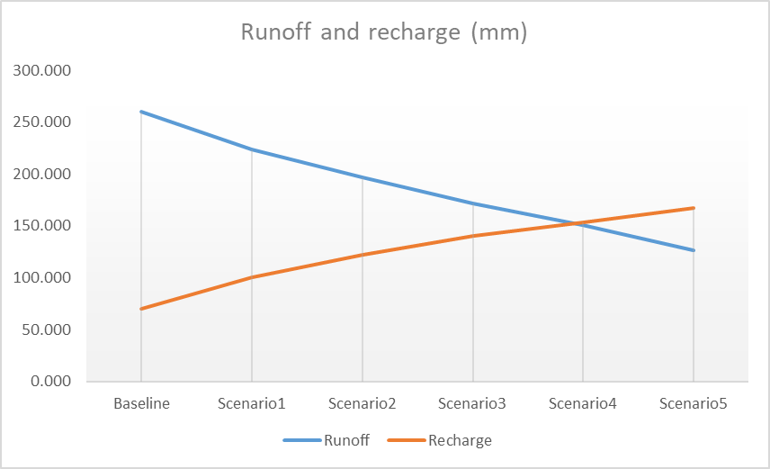

**Figure 7: Impact of interventions on the runoff and recharge in the watershed for mild years**

The impact of increased storage (surface and groundwater) and increased efficiency is visible in increasing yield (shown as % of attainable yield) for different scenarios for wheat (Figure 8).

The main impact of interventions is visible for wheat wherein baseline scenarios only 42% CWR is met (Table 7). Under the increasing intensity of interventions, yield (% of attainable yield) of rabi crop increases from ~40 % in the baseline scenario to ~ 70 % in scenario 5. However, even after scenario 5, their yield remains below 80 % of attainable yield reflecting additional interventions are required to make them drought proofed (defined here as when yield is more than 80 % of attainable yield).

Current supply scenarios are shown to already reduce runoff by 42 % though even after that more than 100 mm of runoff is available for capture. However, any further increase in capture and recharge interventions should consider any potential downstream impacts that may come from capturing large runoff and whether more sites are available for the implementation. There is no scope for irrigation efficiency improving application as already all area of wheat area is planned to be under sprinkler irrigation.

One additional potential strategy could be to shift crop area from high CWR crop wheat to low CWR crops like pulses or coarse cereals or mustard. This will limit the irrigation demand of wheat which is currently very high and surpasses the available irrigation water. Only ~70 % of current CWR is met and shifting 20-30 % area to low CWR crops should be considered as a way ahead for drought proofing watershed in drought years.

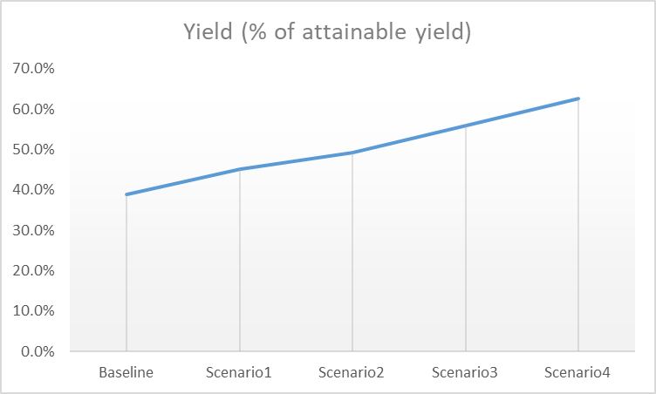

**Figure 8: Wheat yield (% of attainable yield) under different scenarios for mild years**

**Figure 9** shows the impact of interventions on drought proofing quadrant. Increased CWR met and increased efficiency is visible for wheat which is moving further towards the right top corner in quadrant 1 (desirable quadrant). However, despite increased efficiency, CWR met remains around 70 % showing a lack of storage for irrigation. For this, shifting the cultivated area of wheat to low water-consuming crops like pulses or coarse cereals is recommended. As Kharif crops of soyabean and maize are rainfed, interventions focusing on supply and irrigation efficiency don’t show any impact on them.

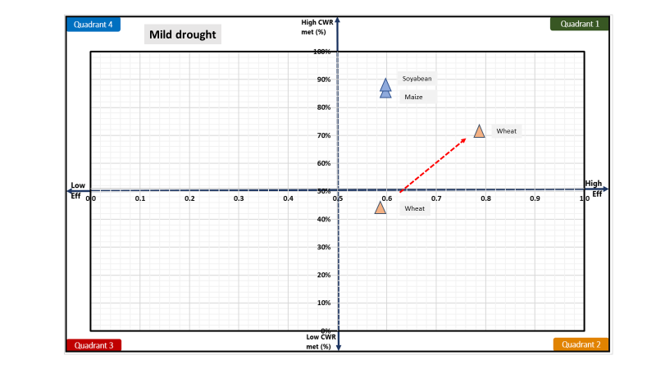

**Figure 9: Impact of interventions visualised on drought proofing quadrant**

**Figure 10** shows the overall watershed drought proofing result for mild years. Percent drought proofing represents total crop production of the watershed as a percent of total potential crop production (i.e. production without any water stress) under different scenarios. The plot shows that drought proofing is achieved to an extent in scenario 5 where drought proofing is almost 78 %. This means that under mild drought if scenario 5 is planned, 78 % of potential production can still be achieved despite the drought.

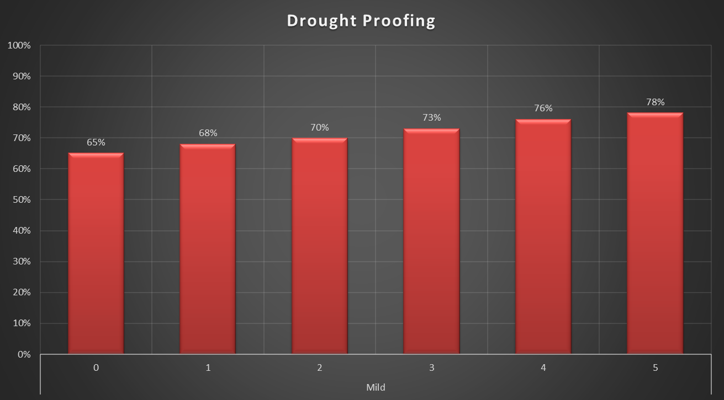

**Figure 10: Overall watershed drought proofing percentage under different scenarios for mild years**

## **Interventions impact on moderate drought**

**Figure 11** shows the impact of interventions on the runoff and recharge in the watershed for moderate drought years. With increasing intensity of interventions, runoff is gradually reduced, and recharge is gradually increased. Compared to the baseline scenario with no intervention, runoff is reduced by 85 % (absolute decrease of 88 mm), and recharge is increased by 195 % (an absolute increase of 65 mm) in scenario 5. Results show that after scenario 5 there is no more available runoff and hardly any runoff leaves the catchment. This reflects the limit of supply-side interventions for moderate drought years. In contrast, mild years had available runoff left after scenario 5 (figure 7). Thus, any further supply measures may benefit crops in mild years but will not do so in moderate drought years. Similarly, the efficiency of wheat increases from 58% (in baseline) to 80% (in scenario 5).

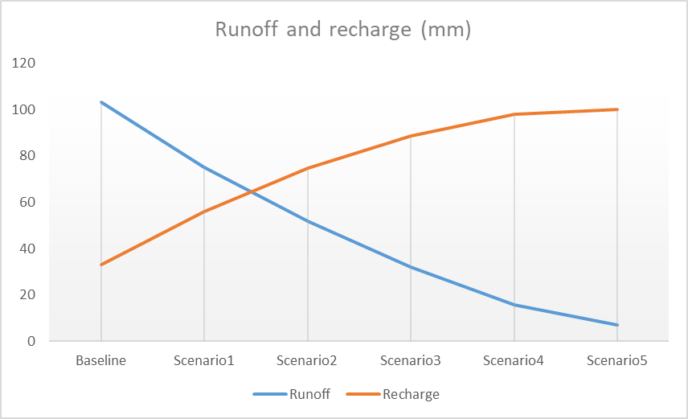

**Figure 11: Impact of interventions on the runoff and recharge in the watershed under different scenarios for moderate years**

The impact of increased storage (surface and groundwater) and increased efficiency is visible in increasing yield (shown as % of attainable yield) for different scenarios (Figure 12). Under the increasing intensity of interventions, yield (% of attainable yield) of rabi crop increases from ~33 % in the baseline scenario to only ~ 50 % in scenario 5. This is much below the 70 % reached in the case of mild years. This is due to limited irrigation storage in moderate years. An increase in storage through a reduction in runoff and increase in recharge not possible further in moderate years as there is no available runoff after scenario 5. There is also no scope for irrigation efficiency improving application as already all area of wheat area is planned to be under sprinkler irrigation.

For moderate years, an additional potential strategy of shifting crop area from high CWR crop wheat to low CWR crops like pulses or coarse cereals or mustard is critical. While in mild years, there was an option between increasing supply interventions or shifting wheat area, in moderate areas latter option is the only real option available. This will limit the irrigation demand of wheat which is currently very high and surpasses the available irrigation water. Only ~55 % of current CWR is met and shifting 30-40 % wheat area to low CWR crops should be considered as a way ahead for drought proofing watershed in moderate drought years.

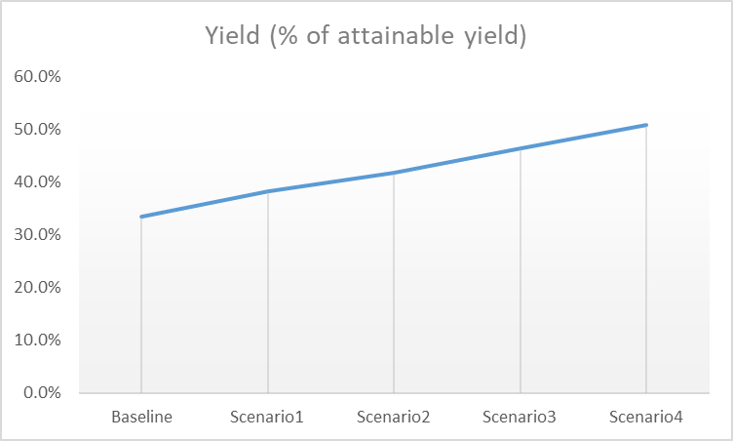

**Figure 12: Wheat yield (% of attainable yield) under different scenarios for moderate years**

**Figure 13** shows the impact of interventions on drought proofing quadrant. Increased CWR met and increased efficiency is visible for wheat which is moving further towards the right top corner in quadrant 1 (desirable quadrant). However, despite increased efficiency, CWR met remains around 55% showing a lack of storage for irrigation. For this, shifting some areas of wheat to low water-consuming crops like pulses or coarse cereals is critical. As kharif crops of soyabean and maize are rainfed, interventions focusing on supply and irrigation efficiency don’t show any impact on them.

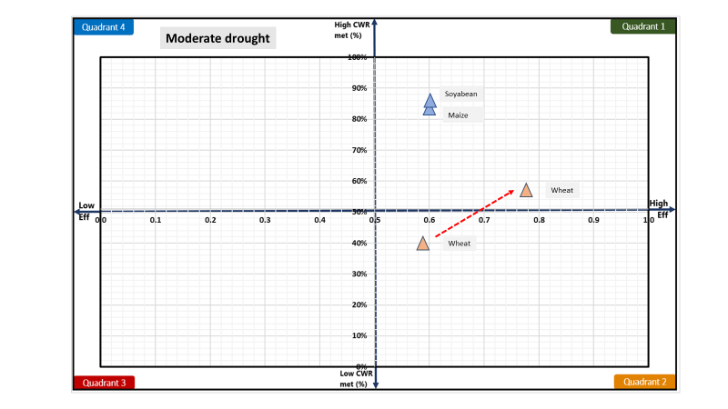

**Figure 13: Impact of interventions visualized on drought proofing quadrant**

**Figure 14** shows the overall watershed drought proofing result for moderate years. Percent drought proofing represents total crop production of the watershed as a percent of total potential crop production (i.e. production without any water stress)under different scenarios. Plot show overall drought proofing is gradually increasing with the intensity of interventions and best is achieved in scenario 5 with drought proofing of almost 70 %. This means that under moderate drought if scenario 5 is planned, 70 % of potential production can still be achieved despite the drought. This is low as wheat remains vulnerable to drought and the strategy of shifting wheat area to less water consuming crop is recommended.

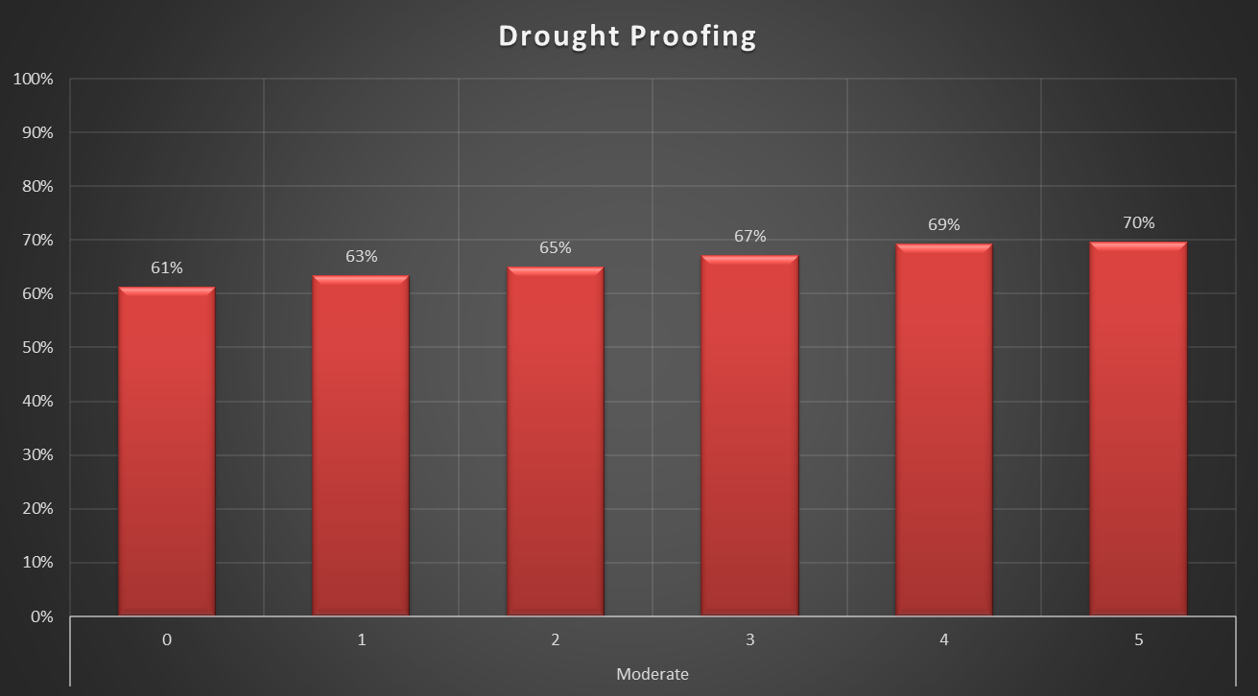

**Figure 14: Overall watershed drought proofing percentage under different scenarios for moderate years**

# **Cost and benefit analysis**

Planned interventions under scenarios entail significant investments for the capital infrastructure and maintenance. Cost and benefit analysis is carried out accounting for the net cost and benefits over a horizon of 20 years with interest rate of 7 %. For more details on how this is calculated, see the [technical manual](https://drive.google.com/drive/u/1/folders/1Yi0Qt4JraRVXNljxe3DB_TAdu5VM8bhg) to see how this is calculated. Very briefly, cost and benefits are analyzed assuming if we had invested in these interventions 20 years ago, what would have been the overall cost and benefits considering the last 20 years of rainfall. Last 20 years of observation is taken as a proxy for future weather.

Results show that to an extent cost and benefits gradually increase with the intensity of interventions. However, for all scenarios, the benefit cost ration (BCR) is near 1.5 showing benefits over 20 years will return 1.5 times the invested amount. High BCR shows for all scenarios. This indicates that though actual best drought proofing results can only be achieved with scenario 5 but incremental benefits for all other scenarios are also beneficial. This provides the rationale for staging investment and planning over the project duration aiming to reach scenario 5.

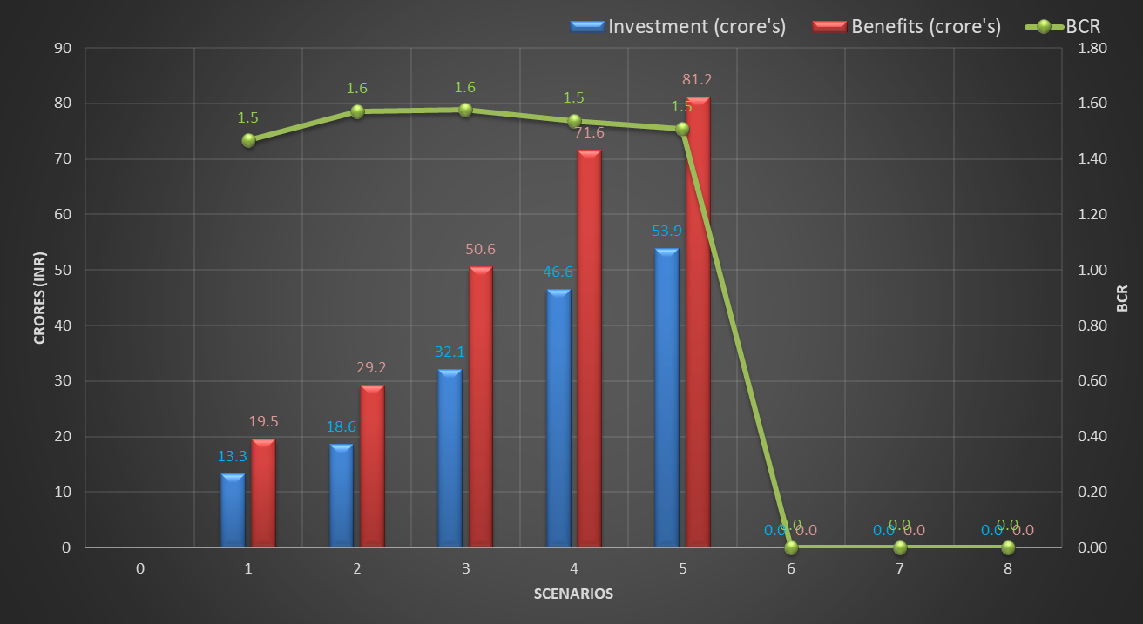

**Figure 15: Cost-benefit analysis**

# **Conclusion and recommendation**

Kulans catchment faces frequent mild and moderate drought. Over the last 15 years, 8 years have been either mild or moderate drought years. Analysis of water balance and deficit shows that drought years significantly impact wheat season crops relying on irrigation. In drought years, the crop yield of wheat is only ~33-40 % of attainable yields. To mitigate the impact of drought, drought proofing measures combining supply and demand interventions are planned. Simulation shows that supply (farm pond, check dams, recharge shafts) and demand (micro-irrigation) can mitigate the impact of drought partially. Shifting of the wheat area to low water consuming crop is recommended for mild drought year in contrast to the alternative of building more supply measures. For moderate years, additional supply measures will yield no benefits, and shifting some wheat areas to low water consuming crops is the only real solution. Cost and benefit analysis show that all scenarios have BCR ~ 1.5, showing the incremental benefits under scenarios are more than the investments. Developed scenarios and results provide the rationale for staging investment and planning over the project duration.

**References**

CGWB, 2013. Groundwater information Sehore district, Madhya Pradesh. Ministry of Water Resources Central Ground Water, Government of India.

Sönmez, F.Kemal., Kömüscü, A.Ü., Erkan, A., Turgu, E., 2005. An Analysis of Spatial and Temporal Dimension of Drought Vulnerability in Turkey Using the Standardized Precipitation Index. Natural Hazards 35, 243–264. <https://doi.org/10.1007/s11069-004-5704-7>

Steduto P, Hsiao TC, Fereres E, Raes D. 2012. Crop Yield Response toWater. Food and Agriculture Organization of the United Nations: Rome, Italy.

World Bank, 2019. Assessing Drought Hazard and Risk: Principles and Implementation Guidance. Washington, DC: World Bank. Link: <https://www.droughtmanagement.info/literature/WBG_Assessing_drought_hazard_and_risk.pdf>

# **Appendix A: Input data**

Table 1A: Land use details

|  |  |  |
| --- | --- | --- |
| **S.no** | **Description** | **Area (ha)** |
| **Total Agri catchment Area (ha)** | | 4328.00 |
|  | Agriculture Area (Net cultivated sown area) | 4064.00 |
|  | Fallow | 47.00 |
|  | Built-up / Settlements | 90.00 |
|  | Waterbodies | 29.00 |
|  | Pasture |  |
|  | Forest | 12.00 |
|  | Waterbodies |  |
|  | Other | 86.00 |

**Table 1B: Soil Data**

|  |  |  |  |  |  |
| --- | --- | --- | --- | --- | --- |
| **S.no** | **Soil Typea** | **Soil Depth (m)** | **Soil Distribution**  **(%)** | **Infiltration Rate (mm/hr)** | **Ground Water Yield of area (l/s)** |
|  | Black cotton | 12 | 100% | 0.5 | 0.70 |

Table 1C: Cropping pattern details

|  |  |  |  |  |  |  |  |
| --- | --- | --- | --- | --- | --- | --- | --- |
| **Area** | **Crop name** | **Area Sown (ha)** | **Irrigation (ha)** | | **Crop Duration (days)** | **Crop Sowing Date** | |
| **Irrigated** | **Rainfed** | **Month** | **Week** |
| Kharif | | | | | | | |
| Area 1 | Soyabean | 3358 | - | 3358 | 90 | June | 4 |
| Area 2 | Maize | 489 | - | 489 | 100 | June | 4 |
| Rabi | | | | | | | |
| Area 1 | Wheat | 3722 | 3722 | - | 125 | Nov | 2 |

Table 1D: Crop details

|  |  |  |
| --- | --- | --- |
| **Crop name** | **Crop yield (tonne/ha)** | **Price (Rs/Tonne)** |
| Soyabean | 0.7 | 35000 |
| Maize | 2.2 | 21000 |
| Wheat | 4.5 | 23000 |

Table 1E: irrigation & domestic details

|  |  |  |  |  |
| --- | --- | --- | --- | --- |
| **Irrigation Source** | **Area (%)** | **Irrigation efficiency** | **Residual storage** | **Non-Renewable storage** |
| Irrigation | | | | |
| **Groundwater** | 85 | 0.5 | 0 | No |
| **Surface water** | 15 | 0.5 | 0 |  |
| Domestic | | | | |
| **Population** | Daily water usage (LPD) | GW dependent | SW dependent |  |
| 8630 | 45 | 100 | 0 |  |